Supplementary material

Supplementary material 1

Interpretation and findings of key laboratory values
The following laboratory tests had been analysed for our patients: blood gas analysis including the partial pressure of oxygen (pO₂), the partial pressure of carbon dioxide (pCO₂), the amount of bicarbonate (HCO₃), the measure of the acidity/basicity (pH), base excess (BE) of blood, blood count, lactate, creatinine, sodium, potassium, glucose, creatine kinase (CK), ionized calcium, bilirubin, C-reactive protein (CRP), alanine, troponin T (TnT), International Normalized Ratio of prothrombin time (INR) and fibrin D-dimers.
Interpretation of key laboratory values
• Sodium (137–145 mmol/L), <134 mmol/L were considered as low
• TnT (women <10, men <15), >15 ng/L were considered as high
• Glucose (4.0–6.0 mmol/L), 7.8–11.0 mmol/L were considered elevated and levels above 11.0 were considered very highly elevated suggesting diabetes mellitus
• CK (women: 35–210 U/L, men: 40–400 U/L), high levels were considered as follows: women >210 mmol/L, men >400 mmol/L (age 18–49) and >280 mmol/L (age over 50)
• Ionized calcium (1.15–1.30 mmol/L), <1.15 mmol/L were considered as low
Abnormal laboratory findings of patients
Most common abnormalities were increased leukocyte count (n = 43) and TnT (n = 34) concentration together with decreased sodium (n = 34) concentration.
• Twenty-one patients had elevated, and 13 patients had highly elevated, glucose levels. Fifteen of all those elevated glucose level patients had diabetes.
• Twenty-four patients had increased CK levels, and in eight of those it was over 1000 mmol/L. The highest CK was 6586 U/L.
• Nine patients had decreased ionized calcium levels.
• Blood gas was analyzed in 23 patients. We found seven mild acidosis, three hypoxemia and one hypocapnia. Patients with abnormal blood gas analyses had either convulsion seizure or shortness of breath, or they were unconscious.
• The highest TnT was 985 ng/L. This patient had difficult chronic atherosclerotic heart disease with arrhythmias, severe renal insufficiency and an implantable cardioverter defibrillator. He died because of a heart attack 10 days post ED admission
• The patient with the lowest pH (7.15) had disturbance of consciousness and breathing difficulty. He had suffered a stroke earlier and this was a sequela of that stroke. He died due to this sequela four days after admission.
• The highest CRP was 98.8 mg/L in a patient with unspecified viral encephalitis.
• Head CT was performed in 82 patients and chest x-ray in 56 patients.

Supplementary material 2

Two examples of EEG recordings
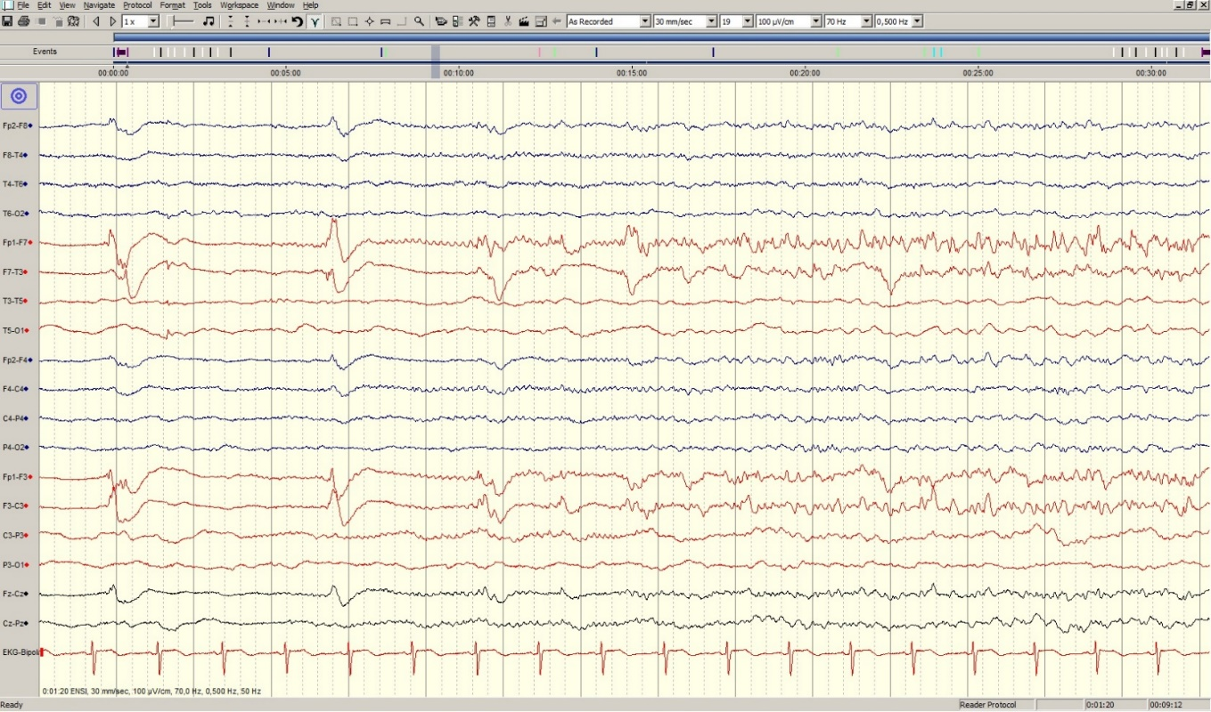
Supplementary Fig. 1. EEG 1: Emerging discharge activity is observed in the left frontal region.

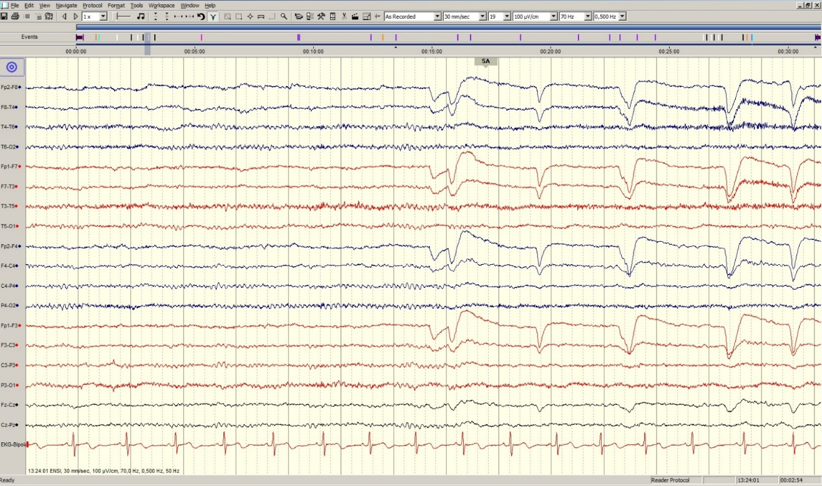
Supplementary Fig. 2. EEG 2: Normal activity (“SA” notation indicates eyes open).

